PATH to WV STATEHOOD

Grade Level: Eighth Grade

Essential Question: West Virginia Statehood: Was it constitutional or treason?

Multiple lessons are included in this lesson that will help students understand how and why West Virginia became a state. Most of the resources given are from http://www.wv.culture.org/history/statehood/statehood.html. This is an excellent resource with resources to be used with your students. We have identified them to save you time.

Assessment: After completing this unit, students will write an opinion letter to the editor of a newspaper on the constitutionality of WV Statehood. Was it constitutional or an act of treason?

Lesson #1 – Causes leading to WV Statehood

What do we want them to know?
- John Browns Raid
- Virginia’s succession from the union
- Disconnection between western Virginia and Piedmont Virginia.
- Issue of slavery and lack of representation.
- Economic and Industrial differences between the 2 regions.

Teaching strategies:
- Students will read Chapter 1, East vs West, http://www.wv.culture.org/history/statehood/statehood.html. and complete the following exercise.

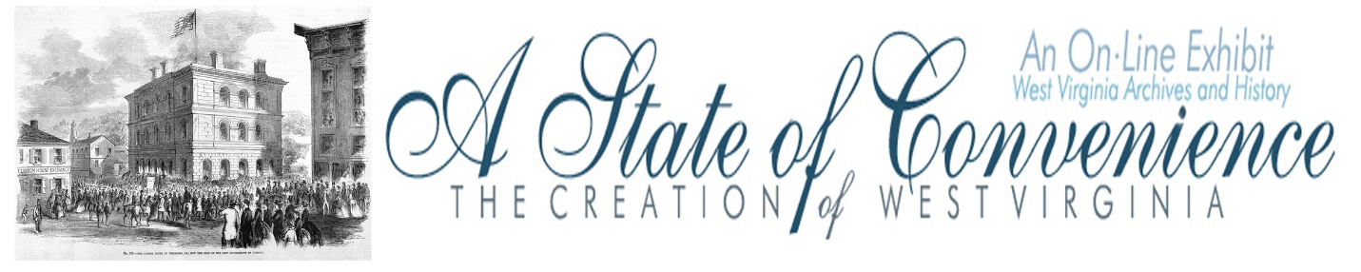

Name ______________________________ Date _______________ Period ________

Directions: Navigate to http://www.wvculture.org/history/statehood/statehoodtoc.html on the internet. Read the Introduction and go to the Table of Contents. Go to Chapter 1: East vs. West and answer the following questions.

East vs. West

1. The image from Howe’s History of Virginia shows two views of Virginia. Describe the differences between these two views in the boxes below.

East | West

2. Who was given voting rights according the Virginia State Constitution adopted in 1776? Who benefited from this provision?

3. When John G. Jackson penned his letter under the pseudonym “A Mountaineer,” how many representatives for the General Assembly came from each county and how many counties were found west of the Blue Ridge Mountains? Why was Jackson upset about this?

4. What were the three main concessions made by Easterners following conventions held in Staunton in 1816 and 1825?

5. What changes did western Virginians want during the Constitutional Convention of 1829-1830? What was the result and how did some westerners respond?

6. What were the results of the Virginia Constitutional Convention (also known as the Reform Convention) in 1850-1851?

7. By the late 1850s what was the relationship between easterners and westerners in Virginia?

8. What impact did John Brown’s Raid at Harpers Ferry have on the relationship between eastern and western Virginia?

Answer Key
East vs. West Worksheet

1. The image from Howe’s History of Virginia shows the two views of Virginia. What are the differences between these two views?

The Eastern view is of a plantation with slaves, while the Western view is of a mountaineer with a small cabin in the mountains.

2. Who was given voting rights according the Virginia State Constitution adopted in 1776? Who benefited from this provision?

The 1776 Virginia State Constitution granted voting rights only to white males owning at least 25 acres of improved or 50 acres of unimproved land. The provision benefited plantation owners in Eastern Virginia.

3. When John G. Jackson penned his letter under the pseudonym “A Mountaineer,” how many representatives for the General Assembly came from each county and how many counties were found west of the Blue Ridge Mountains? Why was Jackson upset about this?

Each county was represented by two delegates no matter what the population was. The west was made up of 4 of the state’s 24 counties. Jackson was upset because many men in the west were unable to vote and they were underrepresented in the General Assembly.

4. What were the three main concessions made by Easterners following conventions held in Staunton in 1816 and 1825?

1. Reapportionment of the Senate based on white population instead of total population including slaves.
2. The Board of Public Works was created to legislate internal improvements like roads and canals.
3. The establishment of state banks in Winchester and Wheeling.

5. What changes did western Virginians want during the Constitutional Convention of 1829-1830? What was the result and how did some westerners respond?

Westerners during the Constitutional Convention of 1829-1830 had hoped to achieve universal white male suffrage and the direct election of state and local officials. The efforts failed and several newspapers in the west called for secession from Virginia.

6. What were the results of the Virginia Constitutional Convention (also known as the Reform Convention) in 1850-1851?

Easterners and westerners agreed to: universal white male suffrage for men over the age of 21; the direct election of governor and judges by the people; and a provision to tax property at its total value, except slaves who were valued at rates below their actual worth.

7. By the late 1850s what was the relationship between easterners and westerners in Virginia?

They were closer politically than they had ever been.

8. What impact did John Brown’s Raid at Harpers Ferry have on the relationship between eastern and western Virginia?

John Brown’s Raid added more tension to the trouble relationship between eastern and western
Virginians.

- Students will analyze a political cartoon on the vote for Virginia’s succession
http://www.wvculture.org/history/teacherresources/politicalcartoonexercise01.pdf
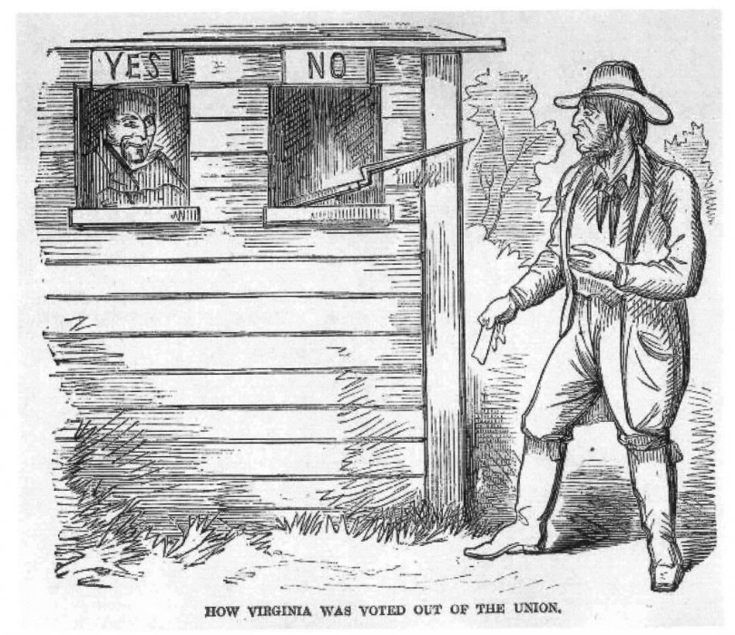

You may use the analyzation worksheets from the US Archives to help students learn how to analyze a political cartoon. The Archives have two worksheets students; the novice and regular. You can use both worksheets in one class to help with lower level readers.

https://www.archives.gov/files/education/lessons/worksheets/cartoon_analysis_worksheet_former.pdf

https://www.archives.gov/files/education/lessons/worksheets/cartoon_analysis_worksheet.pdf

Lesson #2 – FIRST WHEELING CONVENTION

What we want them to know and be able to do:
- Who was in attendance?
- What were their views and concerns with Statehood?
- How were the representatives chosen and why didn’t some show up?
- What other concerns were presented at the convention?

Teaching strategies:
- Students will perform the play, “THE FORMATION OF A NEW STATE: THE FIRST WHEELING CONVENTION”. It is approximately 40-45 minutes long and is designed for one class period. Written by Brenda Stevenson of Heritage Farm Museum and Village, the script is based upon the proceedings of the First Wheeling Convention.
- Teacher will assign parts using the “character and their roles” sheet
- Teacher will interrupt periodically to clarify, to ask questions and hold class discussions, as to various characters and what is happening. i.e. Talk about General Jackson wanting to take his hat and leave the hall (Really? How childish is that?) Review John Carlile’s long speech about the constitutionality of the separation.
- Students may also complete the analysis worksheet from the Online Exhibit, WV History and Archives

Name ______________________________________ Date _______________ Period ________

The First Wheeling Convention

Directions: Go to http://www.wvculture.org/history/statehood/statehood05.html and answer the following questions.

1. When was the first Wheeling Convention held and where did the delegates meet?

2. How many counties were represented?

3. What was the major purpose of the convention?

4. What was the first debate at the convention? How was the problem solved?

5. During the convention what were the two major positions and who were the main supporters of each?
Position 1 | Main Supporters
Position 2 | Main Supporter
6. When was the statewide vote on the Order of Secession?

7. What did the convention decide to do if the Order of Secession passed?
Answer Key
The First Wheeling Convention

1. When was the first Wheeling Convention held and where did the delegates meet?

The first Wheeling Convention was held May 13 – 15, 1861. The convention met at Washington Hall in Wheeling.

2. How many counties were represented?

Twenty-seven counties were represented at the meetings.

3. What was the major purpose of the convention?

The purpose of the convention was to consider and respond to the Order of Secession presented at Richmond.

4. What was caused the first debate at the convention? How was the problem solved?

The first debate at the convention was to determine how counties should be represented and who would serve in the body. The issue was solved by the creation of a Committee on Representation and Permanent Organization.

5. During the convention what were the two major positions and who were the main supporters of each?
Position 1 | Main Supporters
Wait for the statewide vote | General John Jay Jackson, Waitman T. Willey
Position 2 | Main Supporter
The creation of a New State | John S. Carlile
6. When was the statewide vote on the Order of Secession?

May 23, 1961

7. What did the convention decide to do if the Order of Secession passed?

The convention decided to meet in Wheeling on June 11, 1861

THE FORMATION OF A NEW STATE:
THE FIRST WHEELING CONVENTION
MAY 13, 14 AND 15, 1861

NARRATOR: On the 12th of April 1861, Confederate artillery fired on Fort Sumter, in South Carolina. Two days later the convention of Virginia voted to leave the Union. However, an official vote had to be taken for absolute secession. The vote was set for May 23rd, 1861.
On May 13, 1861, a convention of delegates from 27 Western Virginia Counties assembled in Wheeling at Washington Hall. The purpose of this convention was to debate the issue of whether or not to break away from the state of Virginia and form a new state. The report of the committee showed 435 delegates in attendance.
A temporary chairman was appointed, and a prayer was said asking for calm and peace during the convention.
Apparently oblivious to the prayer just said, the delegates immediately break out in an argument over the acceptability of the delegates themselves and they spent the majority of the day arguing over how to decide which delegates to accept. There had been rumors that The Confederate States of America had sent spies to the convention to discover who was there and what their plans were. Many of the men there were frightened.

JOHN BURDETT:
I did not come here to talk. I came here for action. While we are talking, the chains have already been forged for us, and the bayonets are threatening invasion. In my town of Grafton, Letcher has ordered his troops to begin to meet. I tell you it is no time now to display feeling. I trust there will be no more of this, but calm, solemn, stern debate, and a resolve to do what is right to defend and protect ourselves.

NARRATOR:
The Letcher that Mr. Burdett spoke of was John Letcher, governor of Virginia. When Virginians ratified the convention's vote to secede from the Union in May 1861, Letcher became responsible for organizing Virginia's military and government. He seized control of various military resources within the state (the federal armory at Harpers Ferry, for instance), provided for troop recruitment and training as well as for the protection of transportation routes, and worked to secure the dangerously Unionist northwestern part of the state, while at the same time finding some way to fund it all. He began securing commissions for competent militia leaders, such as Robert E. Lee, whom Letcher successfully recruited as major general of land and sea forces, and Thomas J. (Stonewall) Jackson, whom Letcher knew from Lexington, where Jackson had been a professor at the Virginia Military Institute.

CHESTER (C.D.) HUBBARD:
I move that a committee, composed of one member from each county represented on this floor, be appointed, to whom shall be referred the subject of presentation; and also the nomination of permanent officers for the Convention.

NARRATOR:
The motion was adopted and the committee appointed. Next, the convention elected Dr. John Moss of Wood County as permanent President of the convention.

DR. JOHN MOSS:
Permit me to express my grateful acknowledgements for the very distinguished honor you have conferred upon me in selecting me to preside over this highly respectable body.
We have met for the purpose of considering the unhappy condition of our country, and particularly of debating calmly the position Northwestern Virginia should assume in this momentous crisis of our country's history.
Pardon me for saying, gentlemen, that the destinies of thousands are involved in result of your action here, and permit me, therefore, to express the hope that your discussions will be conducted with the seriousness, harmony, and resolution befitting the occasion which is so necessary to the success of any movement that may be decided by this Convention. I again thank you, gentlemen, for the honor you have conferred upon me!

GENERAL JOHN JAY JACKSON SR:
I am opposed to the Convention taking any definite or decisive action; I think it would be premature, and would be revolutionary and altogether unwise. Instead, I am in favor of the Convention passing a series of resolutions expressing its sense of the wrongs of the Northwest. I suggest we adjourn at least until after the election, and urge that in the meanwhile the counties should be appealed to defeat the Ordinance of Secession. When this has been done and every peaceable method of defense exhausted, then I will go in for a division of the State. I believe we might, after a while, and by going about it in the right way, effect a peaceable division of the State, but I would argue that the people of the interior counties are not ready for it yet.

MR. BURDETT:
Suppose in the meantime, while thus waiting, Letcher should throw his troops into this part of the State to intimidate the Union men and carry the election by violence and force, as they will do in the East, which is what he proposes to do in such a case. We must meet this emergency now! Are we to wait till a military dictatorship over-runs our country from one end to another, and freemen's mouths are closed and you are threatened with ropes around your necks?

MR. JOHN S. CARLILE:
Let this Convention show its loyalty to the Union, and call upon the government to furnish them with means of defense, and they will be furnished! There are 2,000 Minnie muskets here now, and more on the way, thank God!

NARRATOR:
The first day of the convention adjourned after Mr. Waitman Willey delivered a lengthy speech in which he took the same grounds as General Jackson. Mr. Campbell Tarr of Brooke County then declared boldly for the position of Mr. Carlile and called for decisive and prompt actions.

DAY TWO OF THE FIRST WHEELING CONVENTION
MAY 14, 1861

NARRATOR:
The convention reconvened at 10 a.m. and the religious prayer was said. The minutes of the previous day were read, amended, and approved.

Mr. Willey stands to clarify his statements from the previous day.

MR. WAITMAN WILLEY:
I believe I was misunderstood last evening. I have been understood to say that my view of the proper course of the Convention was, that it should adjourn until after the ensuing election; without taking any action whatever. I had intended to say that I differed from Mr. Carlile in his views to the proper course to be pursued here. Nevertheless, I wish to declare a distinct and unmistakable position in condemning the take-over by Letcher at Richmond, and lay down a platform upon which to organize the public sentiment for a separation of the State!

NARRATOR:
Colonel Wheat now takes the floor to present the first of the resolutions that he believes the convention should vote on.

COLONEL JAMES SANDERS WHEAT:
I resolve that the ordinance passed by the Convention of Virginia, on the 17th day of April 1861, commonly known as the ordinance of secession, is unconstitutional, null and void.

I resolve that the ordinance suspending and prohibiting the election for members of Congress from this State, to the House of Representatives of the Congress of the United States, required by law to be held on the 4th Thursday of this month is a manifest take-over of power, to which we as Virginia freemen ought not, cannot, and will not submit.

MR. CARLILE:
I understood, I thought, one thing at least, that it was the unanimous determination of this body to consent under no circumstance, to our transfer to the so-called Southern Confederacy. The only diversity amongst us is as to the means of resistance - the means by which this determination will be made effectual.

NARRATOR:
There ensued an argument of considerable time in which Col. Wheat declared his resolutions be referred to the Committee on State and Federal Relations and Mr. Carlile argued that all resolutions touching federal relations were to be referred to and voted on "without debate.”

MR. WILLEY:
According to the resolution that created the Committee on State and Federal Relations, the first business is to refer resolutions to that committee.

MR. CARLILE:
With a view to conciliation and harmony. I am perfectly willing to put it in the shape of a resolution of inquiry.

COLONEL WHEAT:
That will do.

GENERAL JACKSON:
The resolution ought to be referred. I had intended to move an adjournment, but I gave way in order that the gentleman Mr. Wheat might read his resolutions. But now, if this proposition is to be entertained a moment more, I will take my hat and leave the hall, and the delegation from Wood will go with me. I insist my motion to adjourn should be put for a vote.

Mr. CARLILE:
The motion to adjourn has been withdrawn and is not now in order, and besides it will be the grossest injustice not to permit me to explain the motives I have in offering my resolution.

GENERAL JACKSON:
I object, and I insist that my motion to adjourn is in order.

DR. MOSS:
He has the right to explain the resolution to be submitted to the committee.

MR. CARLILE:
Thank you. It has been said here that a proposition looking to a separate State government is revolutionary in its character. I deny it. It is the only legal, constitutional remedy left this people if they do not approve the action of the Virginia Convention.

The Constitution of the United States, which is also the Constitution for Virginia, is the supreme law of the land, and is to be obeyed and respected by all. The Constitution of the United States provides in terms plain and unmistakable for the separation of a State and the establishment of a new State within the boundaries of a State out of which a new State is to be formed. Then, pray tell me, where is there anything revolutionary in discussing and deliberating and exercising a privilege given by the Constitution?
It is a peaceful, legal, constitutional remedy secured to us by the same document which secures freedom of speech and the right of trial by jury. There is no treason, as some gentlemen would endeavor to impress. Therefore I beg members of this Convention to weigh well all arguments that may be addressed to their fears. He who takes counsel from his fears is ill fitted for the emergency in which this people is now placed.
(Applause)

COLONEL WHEAT:
The gentleman from Harrison by extending his remarks beyond what is known as an explanation is arguing the merits of the proposition contained in his resolution and opening the door to general debate, and denying all other members the right to reply to his arguments, thus forestalling the independent action of the Committee. I call to order.

Mr. CARLILE:
I understood the Chair to say if I confined myself to an explanation then I was in order. I have been explaining the first and most important branch of my resolution, which is the peaceful constitutional right of this separation, as I have shown by authority. Any gentleman here has the same right to discuss the question that I have.

DR. MOSS:
Any general debate is out of order until the Committee on State and Federal Relations have reported, but the gentleman has a right to make an explanation. I think though, you are now out of order.

Gen. JACKSON:
I insist that my motion to adjourn has precedence. Mr. Carlile, is out of order.

NARRATOR:
The convention adjourned and since the report from the State and Federal Relations committee was not ready, the convention did not reconvene until 7 o’clock that evening.

DR. MOSS:
We will begin this evening with the report from the State and Federal Relations committee. Mr. George Porter of Hancock County, will you give us the report?

G.M.C. PORTER:
Resolved, That in view of the geographical, social, commercial and industrial interests of Western Virginia, we pronounce the policy of the Virginia Convention in changing the relation of the State to the Federal Government, and annexing us to the Confederate States, unwise and utterly ruinous and disastrous to all the material interests of our section, severing all our social ties and drying up all the channels of our trade and prosperity.

MR. CARLILE:
I agree with the committee’s resolution and I urge this convention to take some action more effective than the mere adoption of paper resolutions.

Mr. WILLEY:
I believe the proposition of Mr. Carlile is in violation of the law, and it is treason not only against the Constitution of Virginia, but against the Constitution of the United States. I believe all the way through that such action will of necessity bring on war in our midst!

NARRATOR:
On motion the Convention then adjourned to 9 o'clock the next day.
After the adjournment someone proposed three cheers for New Virginia, which went up with a wild and almost ferocious yell. Three more were given for Carlile, and the spectators and delegates dispersed.
DAY THREE OF THE FIRST WHEELING CONVENTION
MAY 15, 1861

NARRATOR:
The Convention assembled and was called to order at 9 o’clock. A prayer was said and the minutes of the previous day were read and approved.

MR. WILLEY:
I oppose the organization of a provisional government. It will be treason against the State Government, the Government of the United States and against the Government of the Confederate States of America. It will inevitably bring war and ruin upon this part of the State. I object to such action! I will never lend myself to a rebellious or unconstitutional means of accomplishing an object which I think could be accomplished according to law.

MR. DANIEL POLSLEY:
I am from Mason County, and I am in favor of a separation. I am not terrified by the cry of treason that had been raised here. If there were any treason in the matter we have already committed it. There is no longer any State Government in Virginia. The Governor and authorities have seized and abandoned the rightful Government, and we are now in a condition of anarchy, and it is useless to attempt to disguise the fact. Some kind of an organization must be effected, and the sooner the better. Let us look to the example set by California in her organization. We have the right to establish a provisional government here for the entire State.

MR. CARLILE:
I am willing to take the position the gentleman from Mason County has indicated, if it should be the pleasure of the Convention to recommend the report.

Mr. FRANCIS HARRISON PIERPONT:
I am in favor of the adoption of the report of the Committee on State and Federal Relations; but I am in opposition to the plan of establishing a Provisional Government. I believe Mr. Carlile has unduly over taken this convention and has driven all other gentlemen from the field!

Mr. CARLILE:
I have not said nor done anything authorizing any such inference! I say now to this Convention and to the people of Virginia that I have filled the last office I will ever fill with my own consent.

Mr. PIERPONT:
There will soon be any amount of men and money here to protect Union men in Northwestern Virginia.

MR. CARLILE:
And how do you know this to be true?

NARRATOR:
Mr. Pierpont was about to do so, but on the suggestion of several gentlemen, he refrained. In fact, there almost broke out an actual fist fight between the two.
The convention adjourned for lunch and that afternoon Mr. Carlile tried to convince the members to continue the convention for an additional day.

Mr. CARLILE:
It is now perfectly plain that this convention will not do that which all know I have desired from the beginning. I have received a telegraph dispatch a few moments ago from my own town, informing me that; "The dogs of war are about: look out for State troops.” After the receipt of that letter I think the convention might see the correctness of waiting a day or two longer before taking action. You must come to the conclusion not to adjourn to-night! I move to adjourn till to-morrow at the usual hour.

GEN. JACKSON:
I’m not afraid of Letcher's "dogs of war." Let them come and we will give them a warm reception. I move we adjourn until this evening.

Mr. POLSLEY:
I suggest that instead of acting to-night on the report of the committee, it be laid upon the table and printed, in order that every member might have an opportunity to inspect it.

Gen. JACKSON:
I object; I want to go home. It is corn planting time.

NARRATOR:
Mr. Polsey withdrew the motion.
The question on the adoption of the report of the Committee was then put, and the report was adopted with an almost unanimous "aye," only two dissenting voices being heard.
Prayer was then offered and the Star Spangled Banner sung, and with about three times three hearty cheers for the Union, the Convention adjourned in a perfect blaze of enthusiasm.

LESSON #3 - Second Wheeling Convention
What we want them to know:
- Who was in attendance?
  - How did this differ from the first convention?
- What were the differing views and concerns on statehood?
  - How have these changed from the first convention?
- What other concerns were raised during the convention?
- What were they major issues that caused dissent between those in attendance?

Teaching Strategies:
  - Class presentation on the Wheeling Convention
  - Video on Continental Congress meeting.
  - Writing assignment
    - Using what you learned in the class presentation and from watching the video of the continental congress meeting, what are the similarities and differences that you noticed between the two?
      - Why do you think these similarities and differences are present and do you think that impacted the decisions being made?

Resources:
  - West Virginia Division of Culture and History
    - http://www.wvculture.org/history/statehood/statehood07.html
    - http://www.wvculture.org/history/statehood/statehood09.html
    - Notice the primary documents and other resources available at the WV Division of Culture and History website

  - Video Clip from the Continental Congress.
    - Youtube
    - 1776
    - Other videos

ADDITIONAL RESOURCES:

Google WV Statehood and there are many resources. The following are some we found helpful.

https://www.history.com/news/8-things-you-may-not-know-about-west-virginia

http://www.wvculture.org/history/journal_wvh/wvh30-1.html

https://www.history.com/topics/us-states/west-virginia

https://daily.jstor.org/why-theres-a-west-virginia/

https://aaregistry.org/story/west-virginia-created-by-secession-from-southern-confederate-state/

https://www.archives.gov/legislative/features/west-virginia (this site will lead to several documents including the WV Constitution of 1861)

