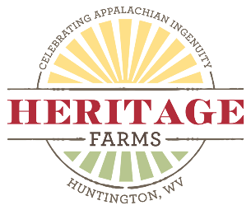 Progress Museum – 1850 - 1925

The Progress Museum at Heritage Farm Museum and Village in Huntington, WV was designed to show the progress in Appalachian living. The “kitchen” exhibits of 1850, 1900 and 1925 are visual representations of the lifestyle changes.
The video, 3 Kitchens in the Progress Museum is approximately 20 minutes and narrated by Audy Perry, executive director of Heritage Farm Museum Foundation. https://www.youtube.com/watch?v=L1XCYsTTZNU

Grade Level: Upper Elementary and Middle School

Essential Question: Why and how was life different in 1850 from life in 1925?

What do we want them to know?
- What is the Appalachian region?
- How was life different in Appalachia from those who lived on the east coast?
- What is progress?
- Compare and contrast what is seen in the 3 kitchens.
- What were reasons for the progress?
- Why problems did our ancestors solve?

Strategies:
- View the video, https://www.youtube.com/watch?v=L1XCYsTTZNU .
- Use the Progress PowerPoint presentation to review with your students what they have heard and seen. Challenge them to improve the toaster or washing machine.

Assessment: Write a one- page essay explaining what “problem” you wish to solve and how you hope it will look 25 years from now. Include steps that must be taken between now and then.

