__________________________________________________________________________________________
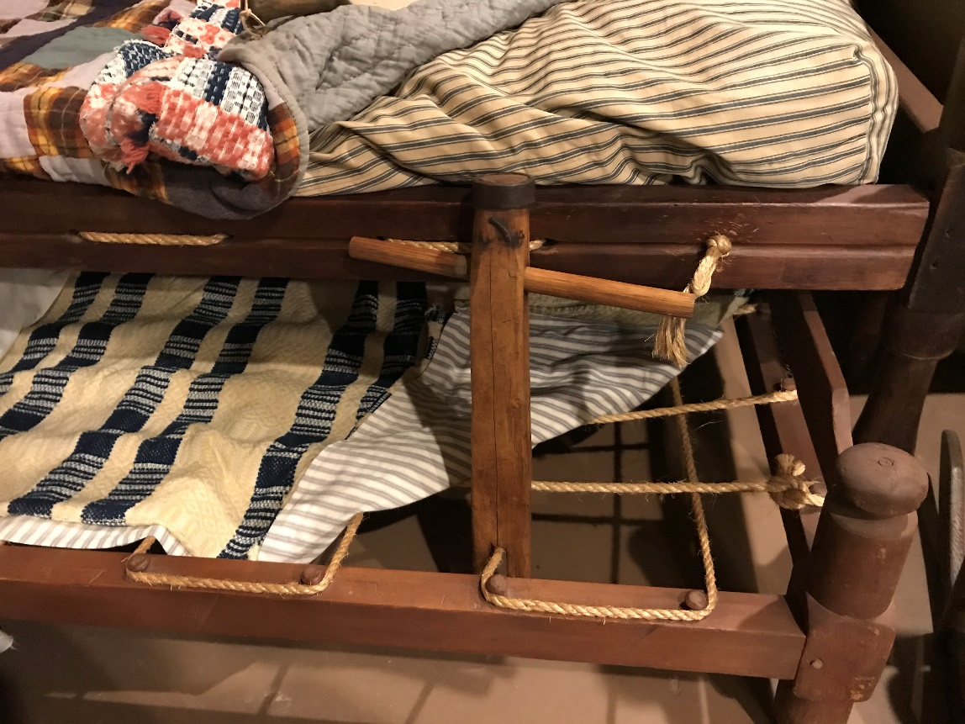

Before or after your visit to Heritage Farm Museum and Village in Huntington, WV you can show your students the video about rope beds.

What do you want them to know?
- How a rope bed worked?
- What was used to make the mattress?
- What does the saying mean, “Sleep tight and don’t let the bed bugs bite.”
- Compare your bed with the early beds in Appalachia.
https://www.youtube.com/watch?v=h5dJxmTAjyg (approx. 2 minutes)

